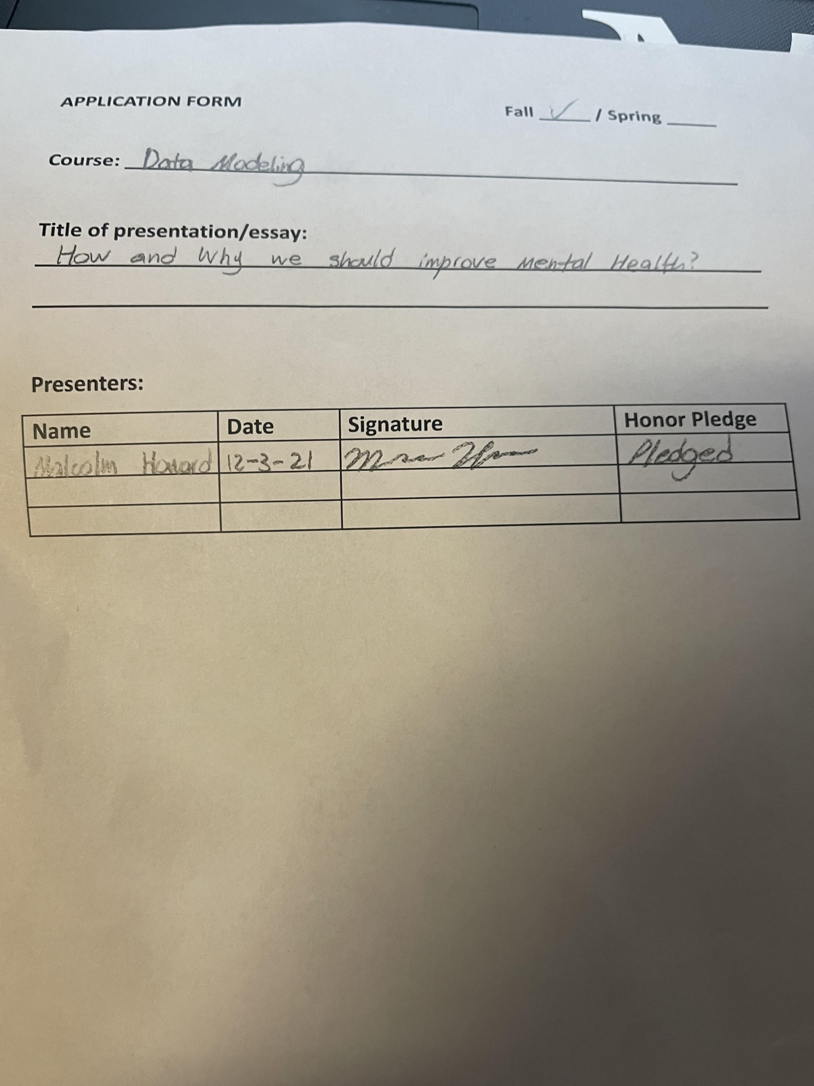

Malcolm Howard

DSC 482

12-3-21

Dr. Birkenkrahe

PLEDGED

How and Why We Should Improve Mental Health?

You ever wonder how someone with the purest heart can turn around and kill him or herself in an instant? The biggest factor in that happening is a person’s mental health. Mental health is an important thing in this day of age and can change the way a person functions at any time. It can affect any person in every age group regardless of the way you live. Our mental affects the way we think, feel, and act. This is why you have people who are energetic and happy all the time because their mental health is doing well while you have people who are depressed and feeling sad or gloomy every time you see them due to a low mental state. Our mental health can be altered by many things.It can be affected by our environment, family, school, sports, work, etc. Almost anything and everything ties in to your health and it could affect you without you realizing it. Your mental can also change out of your control. You could be doing well in life and you could mentally still not be there. This tends to lead to depression and depression can start from an early age. Even though we cannot control every aspect of our mental health, the least we could do as a society that would benefit the country is to help improve our mental health as much as we can. The world would be a better place if we could improve this one thing.

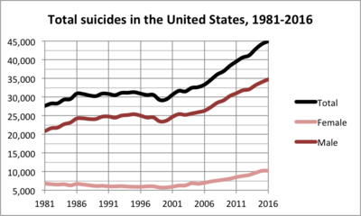

The first reason why we should improve the mental health in the United States because the number of suicides. Suicide is one of the top leading causes of death per year. Based off the information from the Centers for Disease Control and Prevention (CDC) WISQARS Leading Causes of Death Reports (national public health agency in the United States that is under the Department of Health and Human Services), suicide was the tenth leading cause of death overall in the United States in 2019. Suicide took the lives of over 47,500 people. This was twice as many deaths compared to homicides that year which was 19,141. So it was more likely for a person to kill him or herself before someone else would take their life. Even before 2019, the number had been on a constant rise looking back to 1999. From the information of the Centers for Disease Control and Prevention’s National Center for Health Statistics (NCHS), on average, the annual United States suicide rate increased 24% between 1999 and 2014, from 10.5 to 13.0 suicides per 100,000 people. It is getting to the point on average that 132 are killing themselves everyday of the year. There are many reasons on why people feel the need to commit suicide whether it is traumic stress or the fear of loss, but they all tie together to the mind telling them that they cannot keep going anymore. I know times can get tough and be at a low point in life, we all have been there before but we have to find ways to keep pushing forward. We as people need to help the ones we truly love with their problems and even the people we see who are being down so we can improve as a society and lower the number rate of suicide.

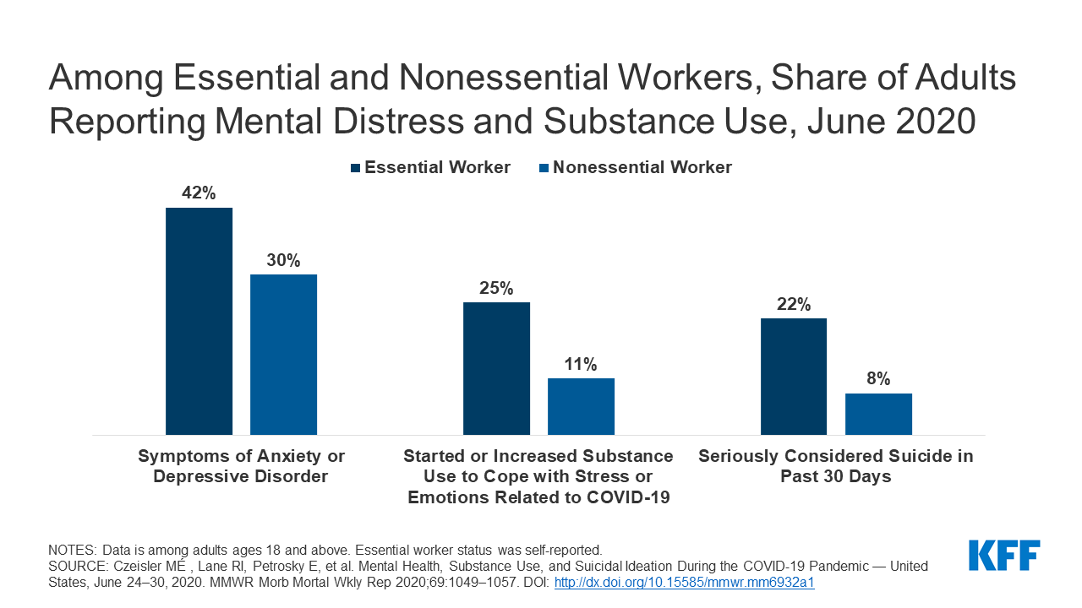

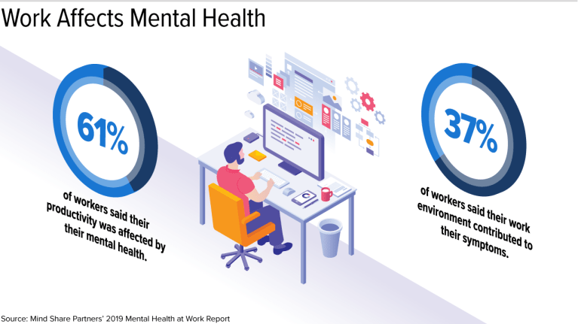

The last reason why we should improve our mental health as a society is because it can help us with being productive people. You will not be motivated to do anything if your mind is not in the right place. From a 2012 study conducted by the Department of Mental Health and Substance Dependence showed that around 200 million work days are missed every year because of depression, and five out of those ten leading causes of disability are related to mental health. Unfortunately, this means that individuals with untreated mental health issues have the possibility of facing economic hardship. Adding economic hardship to the list of problems already will not make things better and will be even more depressing than before. So the better your mental health is, the better your chance of being motivated to get things done and getting things done will lead to better opportunities. These opportunities can range anywhere from a pay raise to help financial needs or just better living conditions.

The first way we can help with mental health and prevent suicide is by communicating with other people. I know there are many people walking around who do not like to talk to others because they are introverted cause I even fall into this category. This can be a long term problem because this introverted trait can lead to holding information that needs to be known or just forcing you to not ask for help. I suffer from this a lot and there are many occasions I should have asked for assistance, but I did the opposite because I never liked to talk to people about my problems or I just felt like I needed to figure things out myself. Since I know I do it, I can infer that others do the same because it is a common human way of thinking. This can lead to anxiety, stress, and depression that can easily be avoided just by one conversation. I made a survey on campus that involved 100 students (55 females and 45 males). The results were no surprise as 68% felt like they could have avoided any type of stress if they decided to speak on their situation instead of trying to handle it themselves. Out of the 68%, 30 were males and the rest were females. Even though I only used 100 people for the survey, you can still see that a majority feel as if communicating their problems can do a lot more than they imagined. I figured it out myself that opening up to someone can relieve so much stress. There were times I actually decided to speak on what was going on in my life and doing that helped me out later down the road. I know I do not do it as enough as I should but I have been going down the right path. To sum it all up, find someone you are close to so you can speak up about the situation you are going through because that can actually save you down the line. Also, check up on the ones you love as long as you are living because you never know what they are going through and you could potentially be saving their lives with that one conversation. A quote from Brian Tracy, who is a motivational speaker, that talks about this is, “Communication is like riding a bicycle or typing. If you’re willing to work at it, you can rapidly improve the quality of every part of your life.”

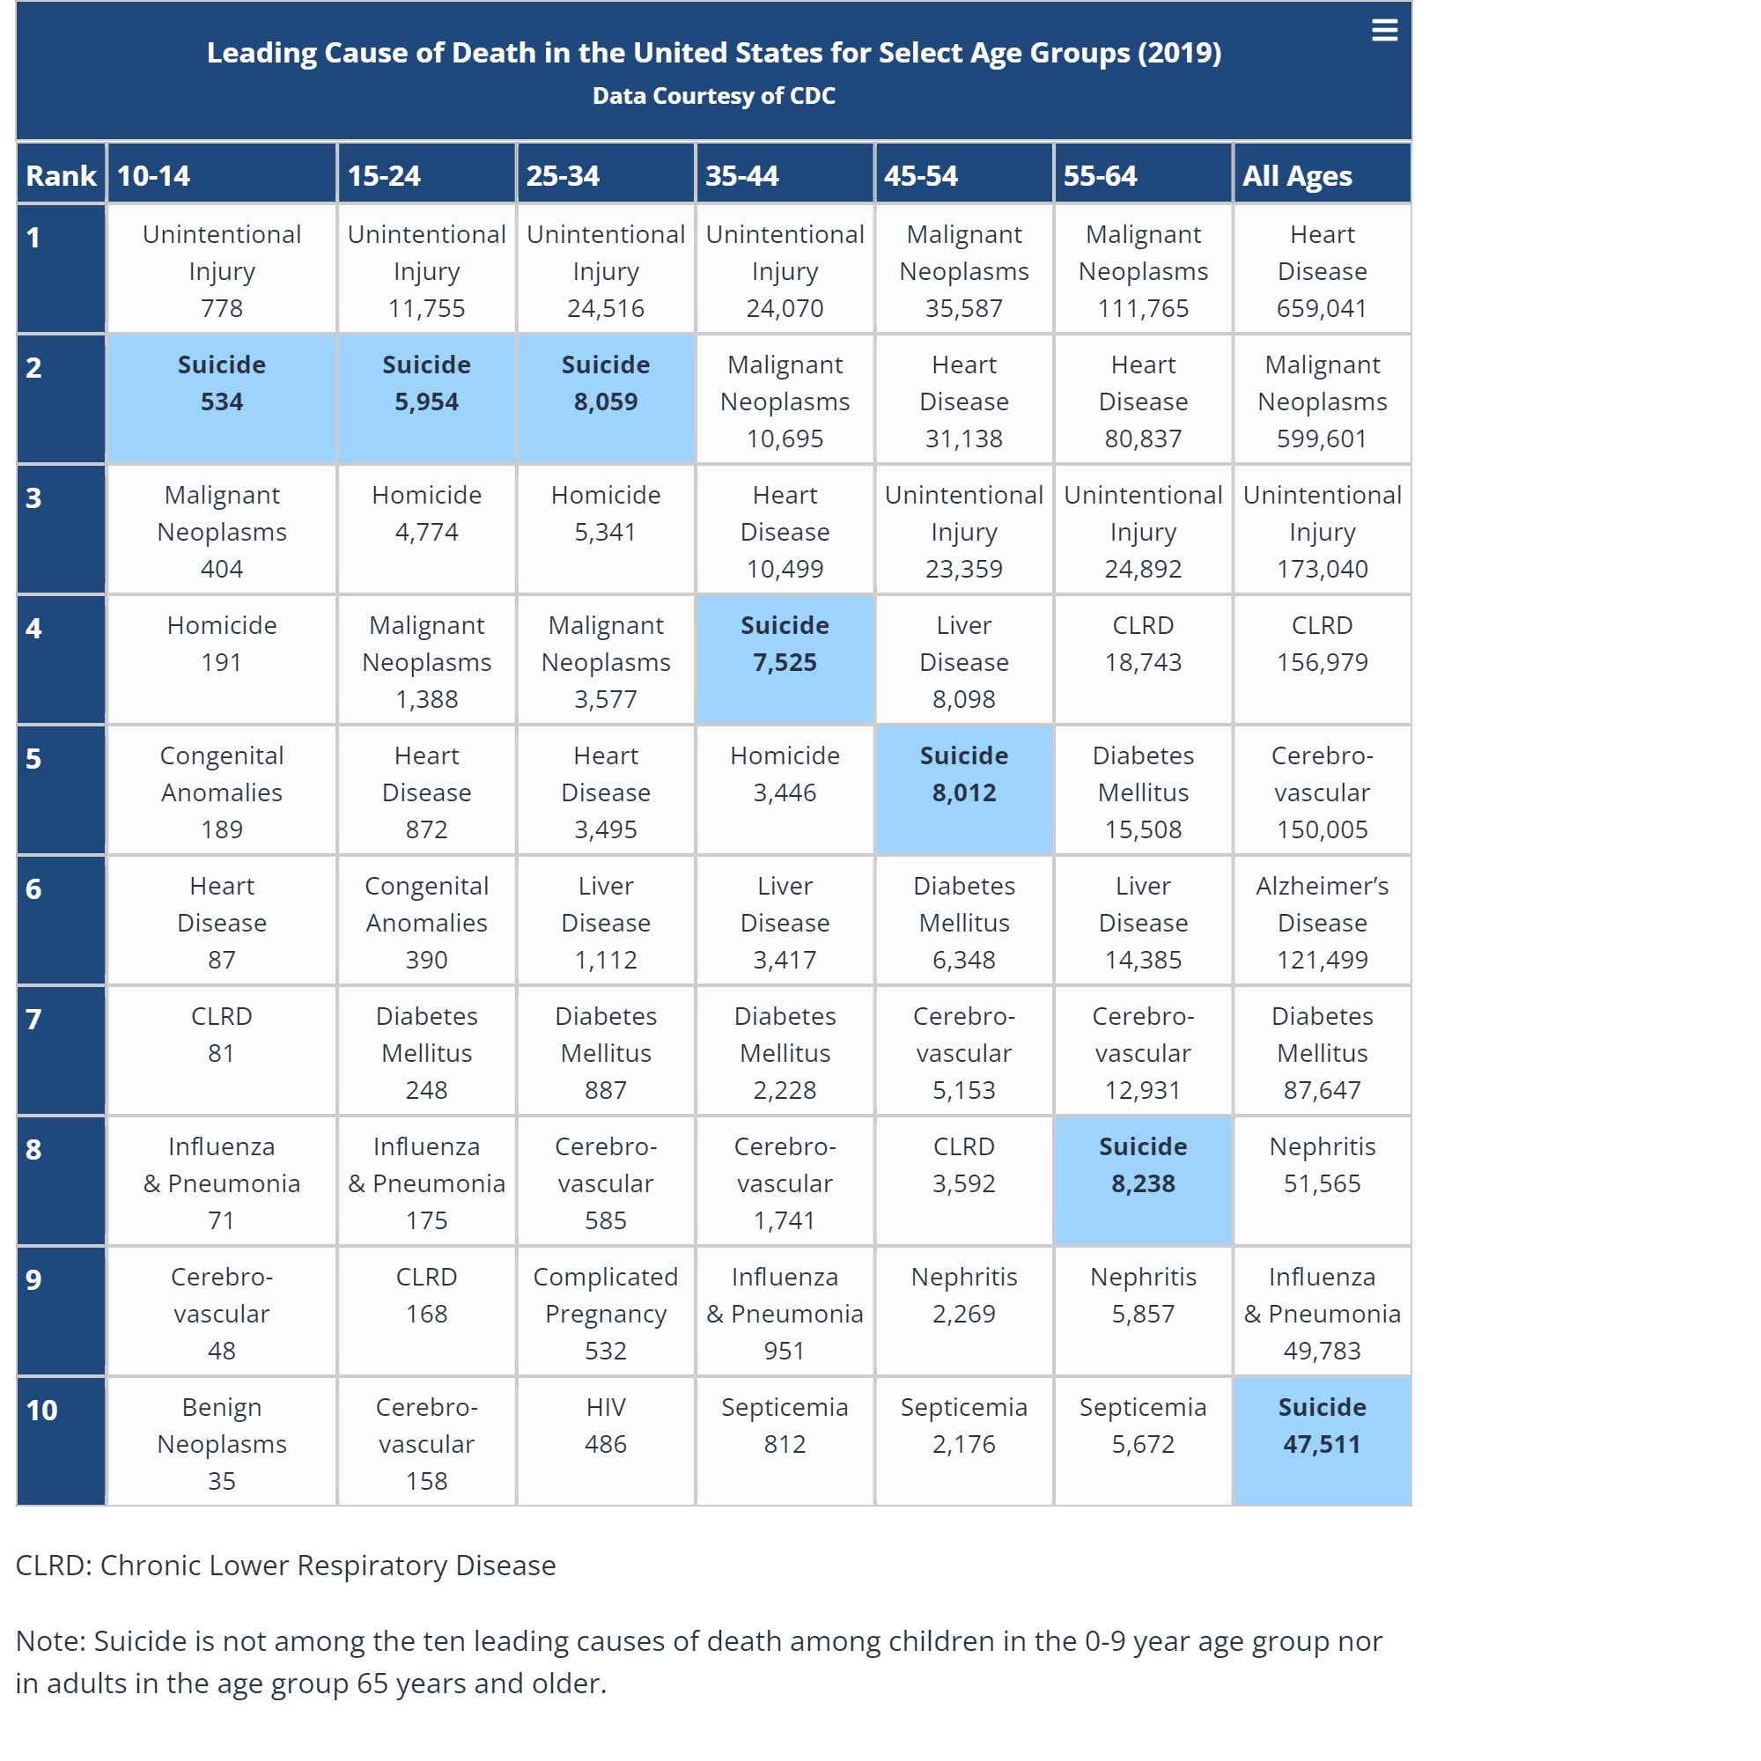

The next thing we can do to help with mental health is by monitoring bullying. Bullying can come in many shapes and sizes. It can result in physical, psychological, social or educational harm. Bullied adolescents are more likely to experience depression, anxiety and sometimes long-term damage to self-esteem. Victims will tend to feel lonely. Some victims may even fight back with violence. Stopbullying.gov reports that in 12 of 15 school shootings, the shooters had been bullied. If the bullied kid does not choose to use violence on others, they will use it on themselves. From the CDC, the data shows that suicide is the second leading cause of death from the ages 10 through 34. This is how you know that bullying is a serious matter when it comes to a person’s mental health. It will cause people to do things that they do not want to do but the anger or sadness built inside them just consumes them. Some ways we can prevent some of these things from happening is by encouraging kids who are victims or a witness to speak up. Most kids are afraid to say anything because of the fear something else will happen. Another way to help monitor bullying is by helping kids understand what bullying is exactly and help them understand that it is not right to do it. Most kids do not understand that what they are doing is wrong and informing them that it is can help a lot. The last thing you can do to help is by showing the kids and teens what are the right things to do in life. Most kids and teens imitate what they see adults do and if they are doing the right thing most will follow along. Bullying is not something that will ever end but just working to make it better will make it better than what is happening currently. A quote by the famous Martin Luther King Jr about bullying states, “In the end, we will not remember the words of our enemies, but the silence of our friends.” Help your friends or anyone in general when they are being bullied. You never know how much of a help you are being.

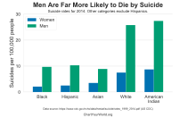

Another thing we can do to help with mental health is by influencing men to open up more. It is a stereotype in the United States for men to be tough with everything they do. Men are supposed to handle every situation with thick skin, not express their feelings whether it is opening up or other things like crying, and they are supposed to be able to be financially stable for a family. Holding all these characteristics can definitely pay a toll on any person and these are just some of the few reasons why men are depressed and mentally unstable. Just like i said they were a toll, This toll is a big factor on the suicidal rate of men. In 2015, suicide was the 7th leading reason of males’ death in the United States. Additionally, men are 3 times more likely to die of suicicde than women. Men suffer from a worse mental state than you can imagine and the only way to fix this is to give them the chance to open up more than they have been.

My final reason why I feel like we need to improve as a society in trying to make mental health important is because I also had suffered from being in a bad mental state on numerous occasions. The occasion I want to talk about though was two years ago which was my freshman year of college. At the time I felt I was fine but looking back I was far from fine. My freshman year, I was away from home on my own for the first time ever so at times I was homesick. Me being homesick affected me more than I thought because I did not get to see my mother's face everyday like I used to, I woke up in a different, uncomfortable bed than I was used to, and I was in an unknown environment. I thought about these factors a lot and they would just make me sad so I was sad more than I ever was. Two more things that did some damage as well was doing college work and starting for the football team. I thought it would be a breeze because I was able to do school work and play football for a long time before then and I thought there was no difference. I came to find out that this was a different beast I was dealing with and I could not do what I been doing if I wanted to be successful in both. So I worked harder than I ever did before to get this done and doing this caused me to be at a very low state. I had to learn new plays every week while learning the playbook. While I had to do that, I had to do constant essays and school work because I was assigned something new every other day. This caused me to not eat much, I stayed in my room, and I did not talk to anyone. I was so worked up on doing good that I lost myself as a person. Not only this, I did not have any friends to begin with being here so I was all alone suffering what I was going through. I did not know where to turn. I wanted to give up and go back home because then I knew I would be happy and be ok, but I chose to stick to it. I finished it out, but I was at a bad point in life, luckily the break came along and I had enough time to regain energy and my mind but I would do almost anything to not deal with that situation again because I was not myself and I did things that I regret to this day.

All in all, these are the reasons why mental health needs to be more focused on in society because it is more effective than people treat it. Our lives revolve around our minds and without the right mind, you cannot go the right path and that is why so many people lost their lives due to it. The greatest thing a person can have is a strong mind and that can take you a long way alone.

References:

* Ali, M. (2018). Communication key ingredient in mental health recovery | MHT. MHT.
* Redirect Notice. (2021). Google.com. <https://www.google.com/url>?
* The Effects of Bullying on Mental Health. (2020, September 21). Best Day Psychiatry & Counseling.
* Assistant Secretary for Public Affairs (ASPA). (2019, September 24). How to Prevent Bullying. StopBullying.gov; StopBullying.gov.
* 4 Reasons Why We Should Take Care of Our Mental Health. (2016, October 10). MISSBISH - Women’s Fashion, Fitness & Lifestyle Magazine.
* ‌Harnois, G., & Gabriel, P. (2000). Geneva 2000.
* National Institute of Mental Health. (2021, May). NIMH» Suicide.
* ‌Wikipedia Contributors. (2019, October 24). Suicide in the United States. Wikipedia; Wikimedia Foundation.